**Acoustic analysis of cement composites with lignocellulosic residues**

Abstract

Key-words

1. **Introduction**

The concept of environmental sustainability has been seeking a way to develop projects that reduce the impacts provided by agricultural development and the excessive consumption of natural resources. All waste produced ~~from~~ by industry and agriculture must be treated correctly, ~~and sometimes it does not happen and it can cause~~ avoiding harmful consequences for the environment (Arruda Filho et al., 2012). According to Madurwar et al. (2013), reuse of such wastes as sustainable construction materials take care of the issue of contamination, as well as the issue of area filling and the expense of building materials.

The use of organic waste has been developed for different applications worldwide, due to the idea of ​​mitigating environmental pollution, as well as proposing recycling alternatives (Prusty et al., 2016). Natural fibers, with their porous cell structure and relatively low density, are becoming ~~increasingly~~ popular because they are renewable, non abrasive, ~~cheaper~~ economic, available in abundance and pose lower health risks during handling and processing (Sari et al., 2016).

The civil construction industry is one of the biggest consumers of natural resources and energy, and this fact has encouraged researches in sustainable development area. The introduction of the concept of “sustainability” in the building sector gradually led to the production of insulation products made of natural or recycled material; some of them are already present in the market while others are still at an early stage of production or study (Asdrubali et al., 2015).

One option to use to lignocellulosic materials in building solutions is the use of cement-bonded particle boards/panels. According to Mendes et al. (2017) these panels are products manufactured from a mixture of Portland cement, chemical additives and particles generated from lignocellulosics. Cement-bonded panels ~~are~~ could be used in building construction ~~for their~~ improving the performance on fire resistance and ~~thermal and acoustic~~ thermal/acoustic insulation. However, there is still little knowledge about the ~~sound~~ ~~absorption~~ acoustic insulation/absorption behavior of lignocellulosic materials. In order to absorb sound, materials should have high porosity to allow the sound to enter in their matrix, and for dissipation (Berardi and Iannace, 2015).

According to Ghofrani et al. (2016) in general, there are two main ways to control noise: The first one is to control/reduce sources of noises~~, namely to build facilities that will produce less or no noise~~. ~~The second is to use sound absorption and sound insulation materials, so sound wave can be diminished or eliminated during transmission~~. The second one is to control/reduce the noise through the transmission path. Hence, it is important to evaluate the acoustic properties of panels produced with lignocellulosic materials. These approaches could be particularly important and useful in developing countries, which do not have well-defined recycling policies and are affected by disposal issues due to large quantities of agricultural and industrial by-products (Asdrubali et al., 2015).

Commercial gypsum board is a widely used building material that can be used for indoor applications. Gypsum boards is an inexpensive material and easy to use with a whole bunch of advantageous attributes. Gypsum boards is considered a material with good properties in terms of heat insulation, comply with the standards for fire safety and provide a pleasant room climate (De Korte, 2015; Butakova&Gorbunov, 2016; Schug et al., 2017).

Therefore, this paper aims to evaluate acoustically cement panels produced with lignocellulosic residues. The panels ~~were~~ are compared with gypsum plasterboard that is frequently or most ~~ordinary~~ common material used as walls and roofs in civil constructions.

1. **Material and Methods**

Five different kinds of lignocellulosic cement composites were developed to be acoustically compared. For each typology of panel, ~~a different~~ the following list of lignocellulosic material residue ~~was~~ has been used: sugarcane bagasse, eucalyptus, banana pseudostem, coconut shell and coffee husk. Three repetitions for each kind of lignocellulosic material ~~were~~ have been made, totalizing 15 panels (5 treatments and 3 repetitions). And three commercial gypsum board were bought at specialized stores in the city.

Lignocellulosic cement composites ~~were made~~ have been developed with high initial resistance Portland cement (CPV-ARI), as mineral binder and calcium chloride (CaCl2), used as accelerator of the cement cure process. For the calculations of the components of each panel (lignocellulosic material, cement, water and CaCl2), the methodology suggested by Souza (1994) was used to determine the equivalent mass of components. In the production of panels, the following parameters were applied: material and cement ratio, 1:2.75; water and cement ratio, 1:2.5; hydration water rate of 0.25; additive, 4% (based on cement mass); percentage of losses, 6%. The calculations were performed for nominal panel density of 1.2g / cm³.

In order to produce each panel, components were weighed and then mixed in a concrete mixer for eight minutes. The total mass of components for three panels equivalent to each treatment (at the same time) was mixed. After mixing, the mass of each panel was properly separated, weighed and randomly distributed in aluminum moulds of 480 x 480 x 150 mm. The moulding and stapling was carried out in a cold process for 24 hours and then panels were kept in a climatic room at a temperature of 20 ± 2° C and 65 ± 3% relative humidity to ensure uniform drying for 28 days.

Thickness (mm), density (Kg m-3) and porosity (%) were developed based on ASTM standard method (ASTM D1037(2016)) and DeutschesInstitut fur Normung – DIN (1982) standards. For the measurement of thickness each panel was used a caliper in 4 points in each sample. The dimensional size and weight measurement were used to calculate the thickness and density of the composites. Density (Kg m-³) was calculated by the relationship between the panel mass (Kg) and the panel size (m³).

The sound ~~transmission loss~~ insertion loss measurement ~~analysis in~~ of the above mentioned ~~different~~ lignocelllosic panels and the commercial gypsum board ~~in comparasion with commercial gypsum board~~ ~~was done with anechoic chamber~~ have been performed using an acoustical treated inexpensive facility developed based on the work of Piedrahita and Fajardo (2012~~). built with inexpensive materials in accordance to Piedrahita and Fajardo (2012)~~. These authors proposed a design for the construction of an anechoic chamber in order to study the sound transmission loss in various materials of daily use such as: styrofoam, cardboard, glass, cotton and sisal, depending on the frequency and sweeping a spectrum in bands of third octave from the 100 Hz to 5,000 Hz.

A schematic representation of the ~~anechoic chamber~~ mentioned facility ~~that was used to measure the sound transmission loss~~ can be seen in Fig. 1.The chamber is divided in two identical parts. The samples are placed in the middle of the two parts and the chamber is sealed by means of clips. The external dimensions of the anechoic chamber are 1.50 x 0.45 x 0.45 m, long, high and wide, respectively. cade a figure 1??

The anechoic chamber consists mainly of an external box made with oriented strand board (OSB wood panel) with 8 mm of thickness and internal layers of different materials. The outer box is basically used to guarantee the insulation with the outside. The inner box was coated of various materials, in order to reduce to the maximum the reinternalexions in its walls, which is one of the main characteristics of an anechoic chamber (Piedrahita and Fajardo, 2012). In this anechoic chamber the internal layers were placed a layer of rock wool (50 mm thick), a simple cardboard sheet layer (5 mm thick), and an acoustic undulation foam with 25 mm (Fig 2). Foam with undulations is to help mitigate the rexions within the chamber. In anechoic cameras this coating it is usually made with different ones or cubes sizes, made of absorbent materials such as polyurethane.

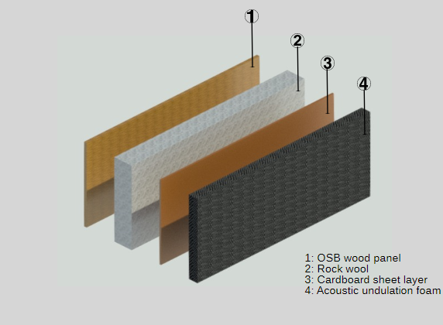

Figure 2. Internal layers of the anechoic chamber.

To be possible to characterize the acoustic behaviour of the studied materials, the acoustic absorption of the different panels produced were analysed according to the NBR 10.151 (ABNT, 2000) taking as variants the sound pressure level for the different frequencies of interest, the position of the microphones, the position of the sound source, the position of the panel, background noise and measurement time. The equivalent sound pressure level was estimated according to NBR 10.151 (ABNT, 2000).

DESCRIÇÃO DOS EQUIPAMENTOS UTILZADOS PARA AS COLETAS DE DADOS. Ex microfones, amplificador, fontesonora, etc

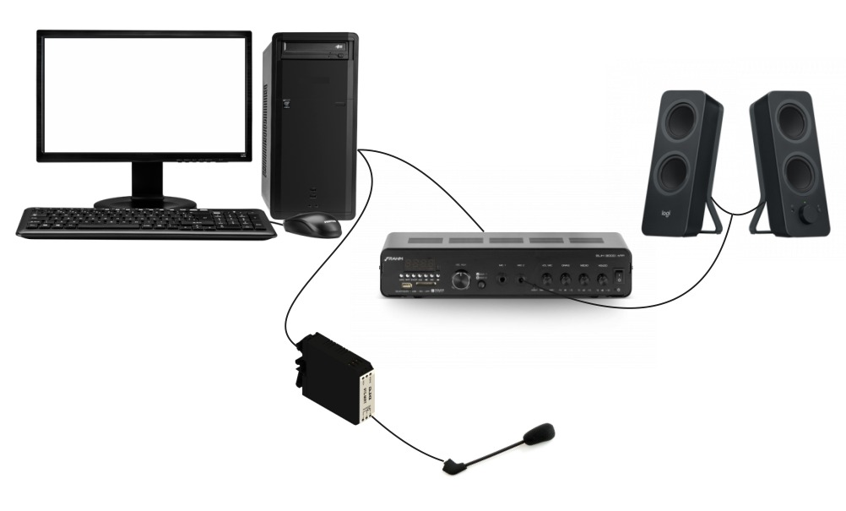

During the acoustic analysis period the environment of the room where the analyses where done were monitored by a hot wire anemometer model HM-385®, measurement scale 0°C a 50°C±1.0°C.

The physical data analysis of the cement composites (thickness (mm), density (Kg m-3) and porosity (%)) were evaluated in a randomized design. The results were submitted to analysis of variance (ANOVA) and Tukey test, both at a 5% significance level.

1. **Results and discussion**

Factors that determine the ability of a material to resist sound transmission include the thickness, density, and stiffness of the specimen (Karlinasari et al. 2012). The researchers of the mentioned work noted that low-density particleboard exhibited lower sound transmission loss values than medium-density particleboard. ~~Karlinasari, L., Hermawan, D., Maddu, A., Bagus, M., Lucky, I. K., Nugroho, N., &Hadi, Y. S.~~ ~~(2012). Acoustical properties of particleboards made from betung bamboo (dendrocalamus asper) as a building construction material. BioResources, 7(4). doi:10.15376/biores.7.4.5700-5709.~~

In the proposed work, the thickness and porosity properties have been measured also besides the density, in order to improve the information of the samples.

|  |  |  |  |
| --- | --- | --- | --- |
|  | Density | Thickness | Porosity |
| Eucalyptus (*euc*) | 1.182 bc | 17.150 a | 74.219 ab |
| Sugar cane (*cana*) | 1.172 abc | 19.968 b | 78.484 b |
| Bananeira (*bananeira*) | 1.003 ab | 16.743 a | 114.363 c |
| Coconut (*coco*) | 0.984 a | 1.819 a | 160.217 d |
| Coffee (*cafe*) | 1.267 c | 16.0383 a | 52.453 a |
|  |  |  |  |
| ~~Coconut~~ | ~~0.984 a~~ | ~~1.819 a~~ | ~~160.217 d~~ |
| ~~Bananeira~~ | ~~1.003 ab~~ | ~~16.743 a~~ | ~~114.363 c~~ |
| ~~Sugar cane~~ | ~~1.172 abc~~ | ~~19.968 b~~ | ~~78.484 b~~ |
| ~~Eucalyptus~~ | ~~1.182 bc~~ | ~~17.150 a~~ | ~~74.219 ab~~ |
| ~~Coffee~~ | ~~1.267 c~~ | ~~16.0383 a~~ | ~~52.453 a~~ |
|  |  |  |  |

|  |  |
| --- | --- |
|  |  |
|  | |

Large differences were observed in the physical properties of the CHF samples

because of their different microstructures as a result of

the chemical treatment of the raw fibers. This diversity is

very interesting because it can provide considerably different

porous microstructures and thus different acoustic properties.

The values of porosity, tortuosity, and airflow resistivity

are listed in Table 1.

Pores isolated from other adjacent pores, also called“closed”pores, allowsome level of sound absorption, but only“open”pores, which guar-antee a continuous channel of communication with the externalsurface of the material, allow higher sound absorption properties[6].Acoustic characterization of naturalfibers for sound absorptionapplications(Berardi and Iannace, 2015)

Results of sound pressure level (SPL) without samples are plotted in the Figure 5. It can be observed, that there are some little differences around 100 Hz and between 200 Hz ans 20 kHz. However, in general the average SPL is around 85 dBL. It is important to mention that for each curve, three measureents have been performed.

Results of sound pressure level (SPL) without and with sample, and insertion loss of samples named as: "euc", "cana", "bananeira", "coco", "cafe" and "gesso", 18fev2019:

1) SPL without sample in dBL. Without sample, they are similar.

The figure 5, show the results of measurements of SPL of the five samples and the reference from 20 Hz to 20 kHz. It can be observed that the level are similar in all the range of frequency, except in 65 Hz, 1590 Hz, 7896 Hz where the response decreased between 10 dBL to 20 dBL, and around 6930 Hz increased 10 DBL, which are assumed to be the characteristic of the local measurement.



Figure5: Results of SPL without the sample

2) SPL with sample in dBL. Lower is better.

The SPL of measurements with samples are shown in the Figure 6. It is important to mention that low values of SP is equivalent to have silent place. As a reference have been used "gesso, blaster bord sample", which is considered as an acoustic barrier. The results of SPL measurements are ploted in the Figure 6. the samples that have been used int the comparative experiment are For the comparative The measurement of sample "gesso", that there are some little differences around 100 Hz and between 200 Hz ans 20 kHz. However, in general the average SPL is around 85 dBL. It is important to mention that for each curve, three measureents have been performed.

The results of SPL measurements with samples can be seen in the figure 6,. It can be observed the reference sample results show low level of SPL in all the frequency spectrum. The analysis for the samples are complex due to the high variation of them in all the range. For this reason it will be adopted three ranges, being: lower than 500 Hz (low), between 500 Hz and 2000 Hz (middle) and higher than 2000 Hz (high). For low range, the eucalyptus and banana pseud presented low values of SPL, being 58 and 64 dBL, respectively. In the other side, the coffee husk and coconut shell presented high values of SPL, 70 and 65 dBL, respectively. In the middle range, the banana pseud presented 40 dBL and two samples, eucalyptus and sugar cane presented around 47 dBL. In this range, the coconut shell presented 57dBL and coffe husk 61 dBL. Finally, in the high range, the sugar cane presented 30 dB followed by eucalyptus with 36 dBL. The coconut shell and coffee husk presented 44 dBL and 48 dBL, respectively.



Figure 6: Results of SPL with sample

3) Insertion loss analysis

The results of insertion loss analysis of the five kind of samples and reference are shown in the figure 7. It is important to mention that for this metric, higher is better, and consequently the insertion loss of the reference sample is the highest for all frequencies. It will be divided the range of frequencies as low, middle and high in similar way as for SPL analysis.

In the range of low frequencies the eucalyptus (28 dBL) and banana pseud (26 dBL) have shown good performance, and coffee husk (18 dBL) and coconut shell (22 dBL) had poor performance. In the range of middle frequencies, the banana pseud (48 dBL) presented the best performance, the eucalyptus and sugar cane presented similar performance (43 dBL), and coconut shell (32 dBL) and coffee husk (28 dBL) presented poor performances. Finally, in the range of high frequencies, the sugar cane (50 dBL) presented the best performance, eucalyptus (53 dBL), banana pseud (50 dBL), coconut shell (44 dBL) have been in middle and the coffee husk (40 dBL) has been the worst sample.

Summarizing, the best in each range were eucalyptus in low, banana pseud in middle and sugar cane in high frequencies. However, in a trade off analysis, the eucalyptus and banana pseud presented good performance in low and middle ranges, and definitely the sugar cane in the high range of frequencies.



Figure 7: Results of insertion loss

1. **Conclusion**

**Acknowledgments**

The authors would like to thank the Minas Gerais State Agency for Research and Development (FAPEMIG Grant n. CAG-APQ-01100-15).

**References**

Akgül, M., Uner, B., Turkey, I., Çamlibel, O., &Ayata, Ü. (2017). MANUFACTURE OF MEDIUM DENSITY FIBERBOARD (MDF) PANELS FROM AGRIBASED LIGNOCELLULOSIC BIOMASS. WOOD RESEARCH, 62(4), 615-624

ARRUDA FILHO, N.; DANTAS, C.P.; LEAL, A.F.; BARBOSA, N.P.; SILVA, C.G.; ALEXANDRE, M.V. Resistênciamecânica de compósitoscimentícioslevesutilizandoresíduosindustriais e fibras de sisal. RevistaBrasileira de EngenhariaAgrícola e Ambiental, v. 16, n. 8, p. 894-902, 2012.

Asdrubali, F., D'Alessandro, F., &Schiavoni, S. (2015). A review of unconventional sustainable building insulation materials. *Sustainable Materials and Technologies*, *4*, 1-17.

ASSOCIAÇÃO BRASILEIRA DE NORMAS TÉCNICAS. NBR 10.151: Avaliação do ruídoemáreashabitadas, visando o conforto da comunidade. Rio de Janeiro, 2000.

Berardi, U., &Iannace, G. (2015). Acoustic characterization of natural fibers for sound absorption applications. *Building and Environment*, *94*, 840-852.

FARINA, A. Advancements in impulse response measurements by sine sweeps. Audio Engineering Society. Audio Engineering Society Convention 122. Vienna, Austria, 2007.

Ghofrani, M., Ashori, A., Rezvani, M. H., &Ghamsari, F. A. (2016). Acoustical properties of plywood/waste tire rubber composite panels. *Measurement*, *94*, 382-387.

Mendes, R. F., Vilela, A. P., Farrapo, C. L., Mendes, J. F., Tonoli, G. H. D., & Mendes, L. M. (2017). Lignocellulosic residues in cement-bonded panels. In *Sustainable and Nonconventional Construction Materials using Inorganic Bonded Fiber Composites* (pp. 3-16). Woodhead Publishing.

Madurwar, M.V., Ralegaonkar, R.V., Mandavgane, S.A., 2013. Application of agro-waste for sustainable construction materials: a review. *Constr. Build. Mater*. 38, 872–878.

Piedrahita, Y., F. Fajardo, Construcción de unaCámaraAnecoica para la Caracterización de la Pérdida de Transmisión Sonora, http://www.scielo.br/scielo.php?script=sci_arttext&pid=S1806-1172012000400005&lang=pt, ISSN 1806-1117, RevistaBrasileira de Ensino de Física, 34(4), 1-9 (2012).

Prusty, J. K., Patro, S. K., &Basarkar, S. S. (2016). Concrete using agro-waste as fine aggregate for sustainable built environment–A review. *International Journal of Sustainable Built Environment*, *5*(2), 312-333.

Sari, N. H., Wardana, I. N. G., Irawan, Y. S., &Siswanto, E. (2016). Physical and acoustical properties of corn husk fiber panels. *Advances in Acoustics and Vibration*, *2016*.

Souza, M. R. (1994). Durability of cement-bonded particle board made conventionally and carbon dioxide injection. These (Doctor of Philosophy)–University of Idaho, Idaho, 123p.

Schug, B., Mandel, K., Schottner, G., Shmeliov, A., Nicolosi, V., Baese, R., ... &Sextl, G. (2017). A mechanism to explain the creep behavior of gypsum plaster. Cement and Concrete Research, 98, 122-129.

Butakova, M. D., &Gorbunov, S. P. (2016). Study of the Influence of Complex Additives on Properties of the Gypsum-Cement-Puzzolan Binder and Concretes on its Basis. Procedia engineering, 150, 1461-1467.

De Korte, A. C. J. (2015). Hydration and thermal decomposition of cement/calcium-sulphate based materials (Doctoral dissertation, Ph. D. Thesis, Eindhoven University of Technology. https://research. tue. nl/en/publications/hydration-and-thermal-decomposition-of-cementcalcium-sulphate-bas).





